News from the Call Committee!!!
We are very blessed to be able to announce our new pastor will be Pastor Beth Pottratz. Her ordination will be at her home church in North St. Paul on August 5th and she has invited any and all of our congregation to join her for this joyous occasion. She will begin her ministry here in mid-August. She has sent an introductory letter that follows.
We all welcome her!!!
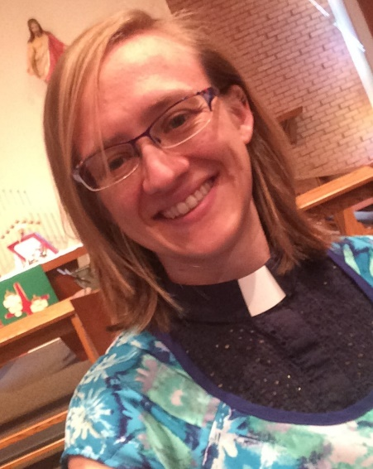
Greetings, Salem Lutheran Church!
Grace and peace to you from God our Father and from our Lord and Savior Jesus Christ.
I give many thanks to God and to you for the opportunity and blessing to serve as your pastor in Mahtowa! I am truly very excited to get to know each of you, the congregation, and the community! Throughout the interview process and visiting Salem I have loved learning about all of the various ministries going on at Salem and look forward to learning more, as well as becoming part of the ways in which you are spreading the message of Jesus’ love.

I was asked to write an introduction for the newsletter, so I hope to tell you a little about myself so that you can start to get to know me as well. I grew up in Maplewood/No. St. Paul, an eastern suburb of St. Paul, but some of my family roots go back to the Iron Range/North Woods of MN where we visited every summer. My family includes my parents, two sisters, brother-in-law and my best friends. My sisters work in teaching and social work. My best friend and her husband are in ministry in the UP Michigan and their daughter (born last August) is also my goddaughter.
Before starting seminary to become a pastor, I started a career as a Spanish teacher at a high school in inner-city Minneapolis called Augsburg Fairview Academy. Both this job as a teacher at Augsburg Fairview as well as becoming involved at a former congregation called El Milagro were the final pushes that I needed to hear God’s call for me to pastoral ministry. Other major life experiences that led to my call to ministry include: growing up involved at St. Marks Lutheran Church in No. St. Paul, four summers working at Luther Park Bible Camp in Chetek, WI, and one year living and working in Montevideo, Uruguay with Young Adults in Global Mission (YAGM) program.
During my time at Luther Seminary, I was shaped by being involved in three different smaller congregations in Minneapolis, a summer internship as a chaplain at Park Nicollet Methodist Hospital, and a year long pastoral internship at Redwood Central Lutheran Parish in small town/rural southwest Minnesota.

(over)

(continued from page 1)
I am passionate about knitting and you will probably frequently find me with a current project close by. In addition to knitting, in the past year I have also learned how to spin yarn, nalbinding (another yarn art), and Hardanger lace. My current favorite TV show is Parks and Recreation. I also enjoy language and learning about other languages and cultures. I like to cook, especially making soups in the winter. I do not have any pets, but enjoy taking care of my plants. My spider plant is doing exceptionally well right now and I am very proud of it!
My favorite author is Brené Brown; my favorite quote from her is “You are imperfect, you are wired for struggle, but you are worthy of love and belonging.” My favorite story from the Bible is the story of Jesus with the Samaritan Woman at the Well, John 4:1-42. One of my favorite verses is Micah 6:8 “And what does the Lord require of you but to do justice, and to love kindness, and to walk humbly with your God?”
My ordination, as a service of blessing from the Holy Spirit and the church on the start of my ministry as a pastor, will be on August 5th in the evening at St Mark’s in North St. Paul. You are each invited to join me for this special day, more details to follow later. I look forward to seeing you all soon and getting to know each of you as I begin as pastor of Salem Lutheran later this summer!
Peace and blessings!!
Pastor Beth Pottratz

.

Church Directory
Church Council:
Jason Marsh, President
(218) 355-0459
Brent Speldrich
Dave Eller
Zach Langhorst
Caleb Anderson
Jeff Gilbertson
Donita Korpela

Parish Nurse
Joanne Bislow
(218) 428-7696

Custodian
Chuck Porter
(218) 260-7553

Church Secretary
Pat Butcher
(218) 341-2147
mncharley@aol.com

Organist
Jean Hendrickson
(218) 485-8946

Pulpit Supply
Pastor John Estrem
(218) 389-9772

Luke Lekander, Seminary Student

Mahtowa Hootennany
Saturday, July 9th
12:00 Noon – 8:00 p.m.
Free Admission
Music will be on the lawn in front of Salem’s Mahtowa Hall. Bring a lawn chair or blanket and enjoy the sunshine. Pulled Pork Sandwiches fresh off the spit with sides made by the ladies of Salem Lutheran available for purchase in Salem’s Mahtowa Hall.

The Line Up

12:00 Noon – 1:15 p.m. – Nate Frazer & Howie Wilkes

1:45 p.m. – 3:00 p.m. – Feeding Leroy

3:30 p.m. – 4:45 p.m. – The Fish Heads

5:30 p.m. – 8:00 p.m. – Salem’s own Holy Hootenanners

Upcoming Events –
August 8-12 – Kids Bible School at Covenant Park Bible Camp on Park Lake. Grades Pre K-6. Sign up on line or you can pick up an information brochure at church.
August 22 – Worship at Carlton County Fairgrounds.

10 Warning Signs of Good Health
- Persistent presence of supportive friends.
- Chronic positive expectations – a tendency to frame events in a positive light.
- Regular signs of joy in living.
- Increased sensitivity to others.
- A tendency to adapt to changing conditions.
- Increased appetite for physical activity.
- Tendency to identify and communicate feelings.
- Repeated episodes of gratitude and generosity.
- Compulsion to care for other people.
Persistent sense of humor. Known to laugh out loud

